**Project Report**

1. Title.
2. Description.
   1. Overview.
   2. Key Features.
3. Participants and their respective roles in the project.
4. Screenshots demonstrating the execution of the application.
5. Github Link.

* **Title :**

VASTHRA – Online Clothing E-Commerce Application.

* **Description :**
* **Overview :**

Vasthra is a full-stack online clothing e-commerce application developed to provide users with a seamless and interactive shopping experience. The application integrates a responsive frontend with a robust backend, allowing users to browse products, view categories, and access detailed product information using a collaborative development approach that emphasized discussion-based problem solving and complete understanding of the application flow.

* **Key Features** :
* Responsive and user-friendly frontend using React, HTML5, CSS3, and JavaScript.
* Backend developed using Spring Boot and Spring Data JPA.
* MySQL database for secure and structured data storage
* RESTful APIs for the frontend-backend communication.
* API testing and validation using Postman
* API documentation using Swagger
* Product and category management functionalities
* Smooth and consistent end-to-end application flow.
* **Participants and Their Respective Roles in the Project :**
* **Team Collaboration and working Methodology**

The Project was developed using a collaborative team approach without a designated team lead, where all members equally contributed and participated in decision-making. The project was carried out through continuous and structured daily collaborative sessions, and tasks were not divided among the team members. Instead, the entire team worked together on each module of the application. During every session, one member shared the screen and handled the implementation, while the other members actively participated by observing the code, sharing ideas, asking questions, and suggesting improvements. Whenever issues or errors occurred-whether related to frontend UI, backend logic, database connectivity analyzed the problem and discussed multiple approaches before arriving at a solution.

Though this discussion-based problem-solving approach, all members gained a complete understanding of the end-to-end flow of the application, including frontend development using React, backend development using Spring Boot and JPA, database interactions with MySQL, API testing using Postman, and API documentation using Swagger. This collaborative methodology strengthened teamwork, communication, and technical clarity throughout the project …

* **Role of the Team Members** :
* **Shravya (M1) :**

I actively participated in daily discussions and screen sessions by contributing ideas, reviewing code, and analyzing issues along with the team. By collaboratively solving every problem, I gained a complete understanding of frontend-backend integration, API execution, and the overall application workflow.

* **Divya (M2) :**

Actively participated in daily collaborative and screen-sharing sessions by contributing ideas and reviewing frontend implementations. Through group discussions, gained a clear understanding of React component structure, UI flow and user interaction handling. And integration of the end-to-end application and understanding in the backend logic too

* **Shubham(M3) :**

Contributed during collaborative problem-solving sessions by analyzing database operations and API responses. Gained clarity on MySQL schema design, data flow between layers, and API testing using Postman and Swagger.

* **Sai(M4) :**

Actively engaged in discussions during development and helped analyze integration and execution issues. Understood frontend-backend integration, JSON data handling, and the end-to-end application execution flow.

* **Jeevan (M5) :**

Participated consistently in discussions related to backend development and frontend UI part during the shared sessions. Developed a strong understanding of spring Boot architecture, REST API design and data persistence.

* **Umair ( M6)**
* **Mohsin (M7)**
* **Screenshots Demonstrating the Execution of the Application :**
* **Landing Page**

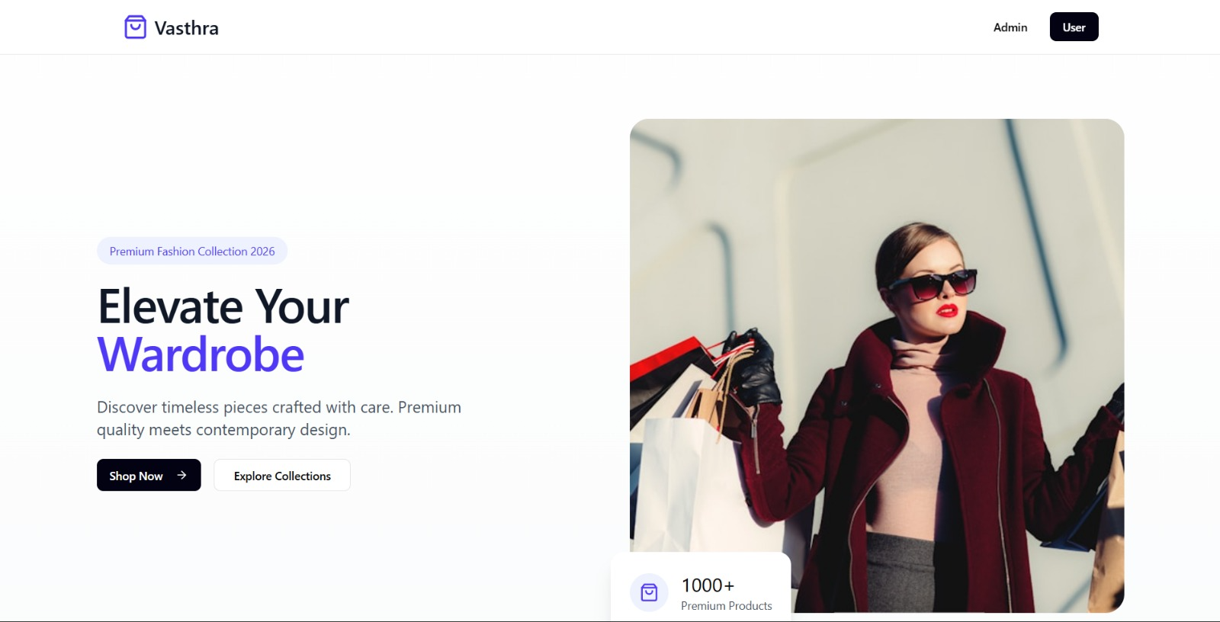

**Footer**

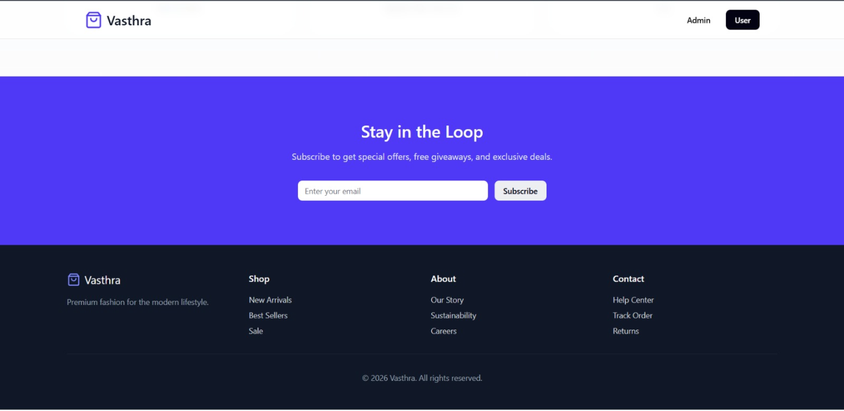

* **Admin’s Login Page**

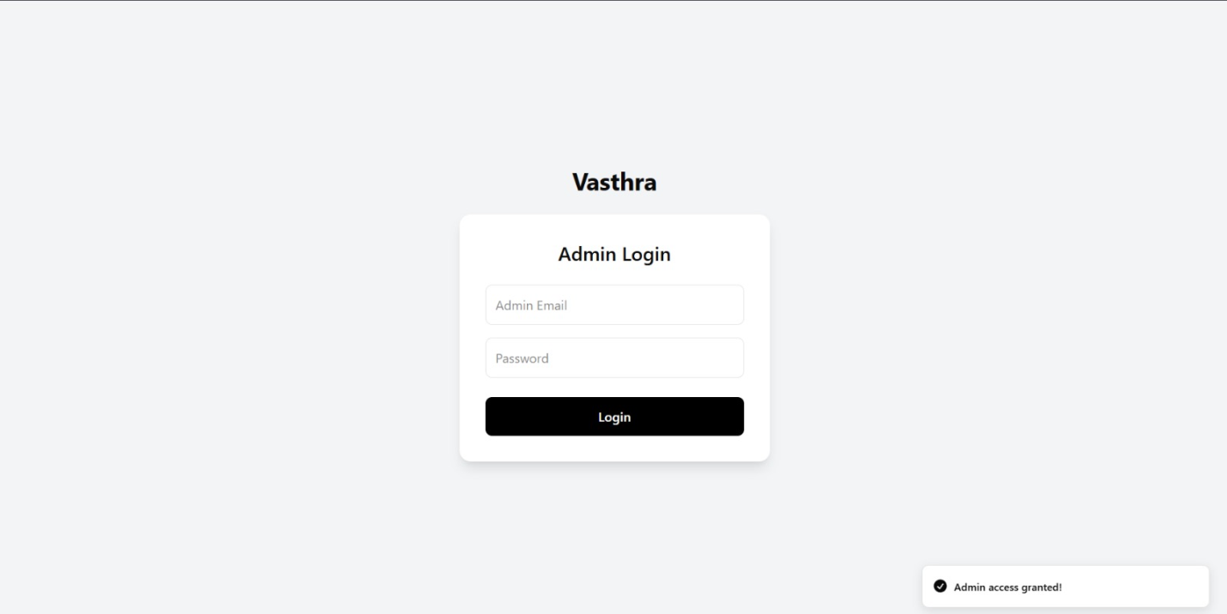

* **Registration Page**

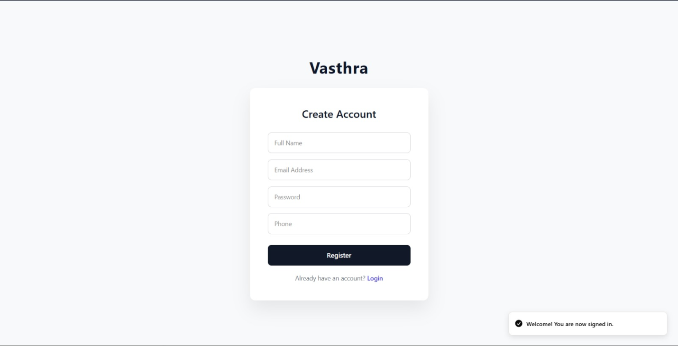

* **User Login Page**

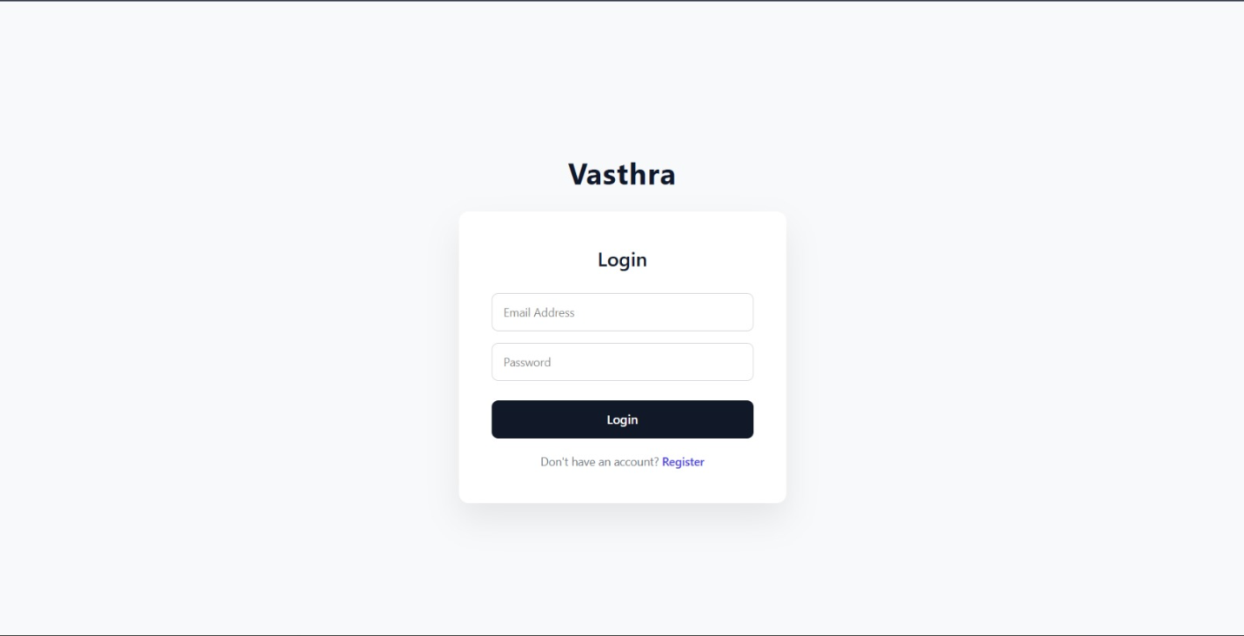

* **Admin Dashboard Page**

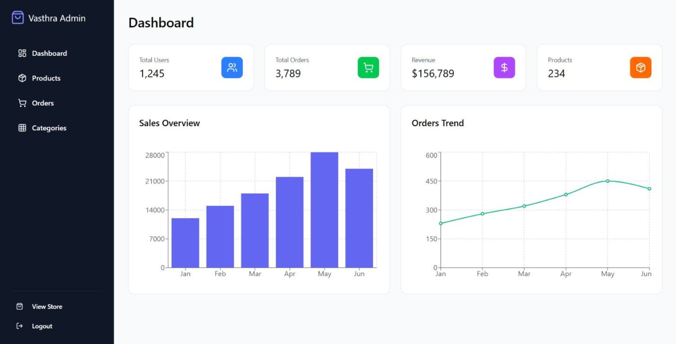

* **Admin Category Page**

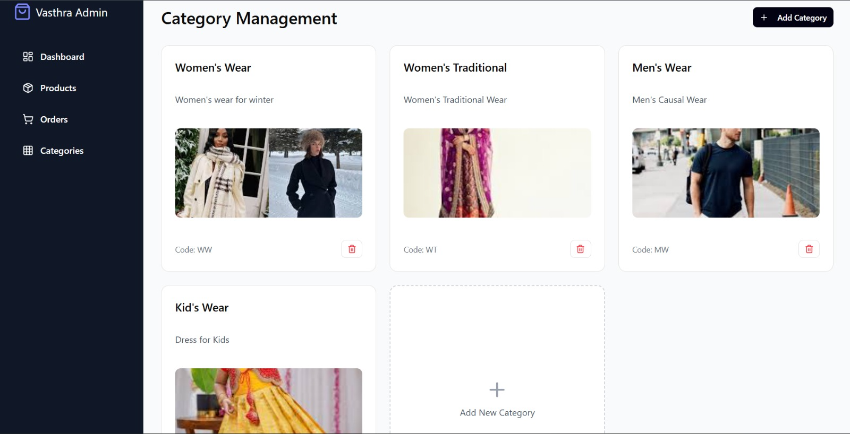

* **Admin Product Page**

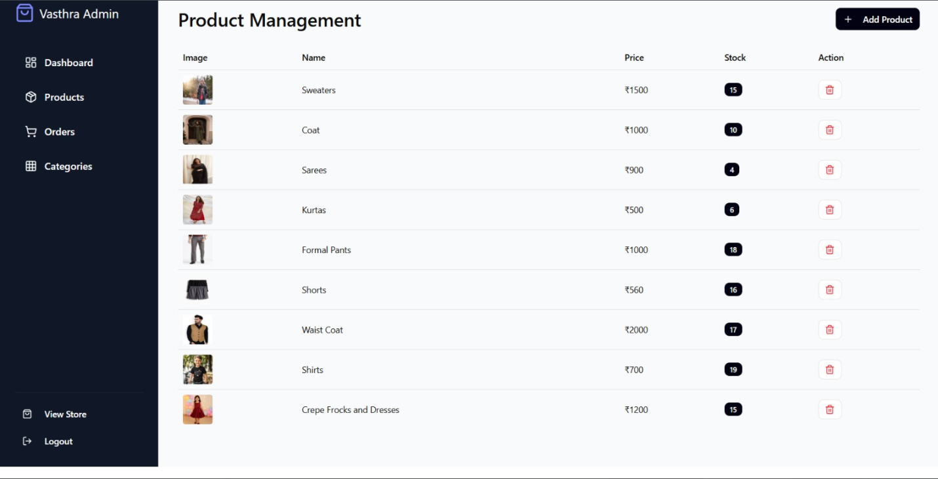

* **Admin Order Page**

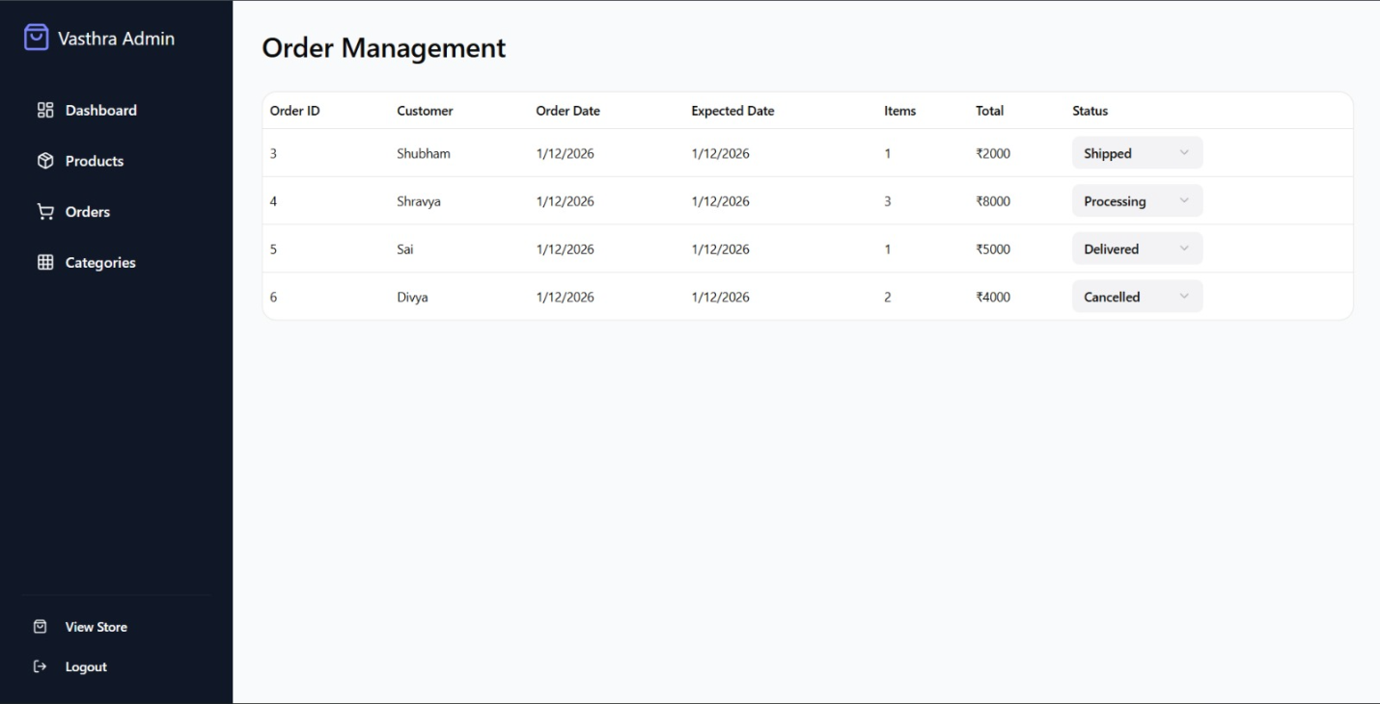

* **Home And product Page**

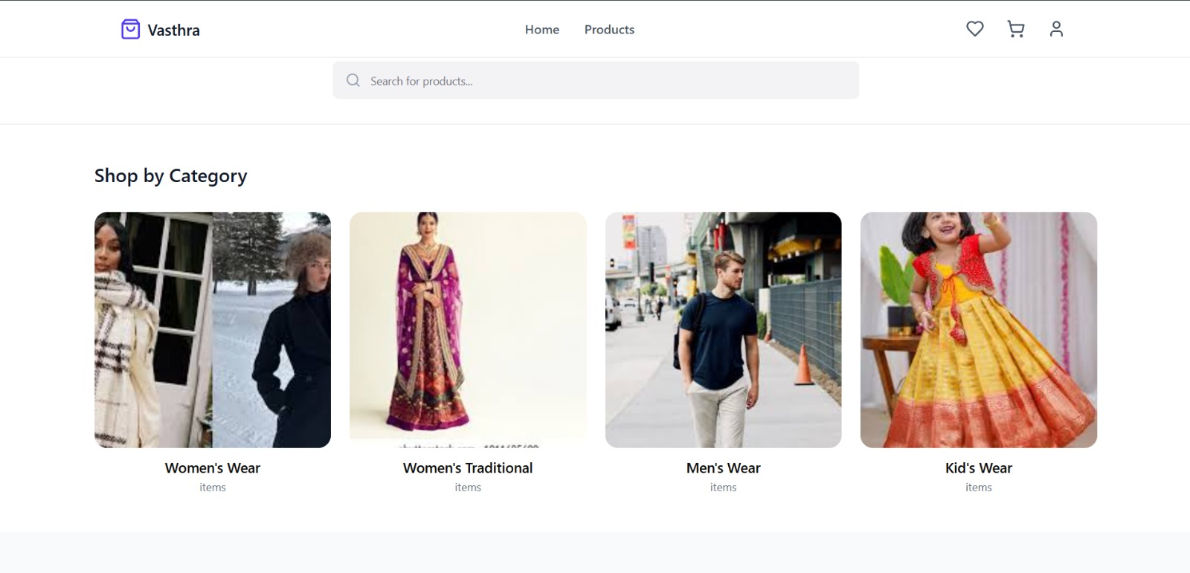

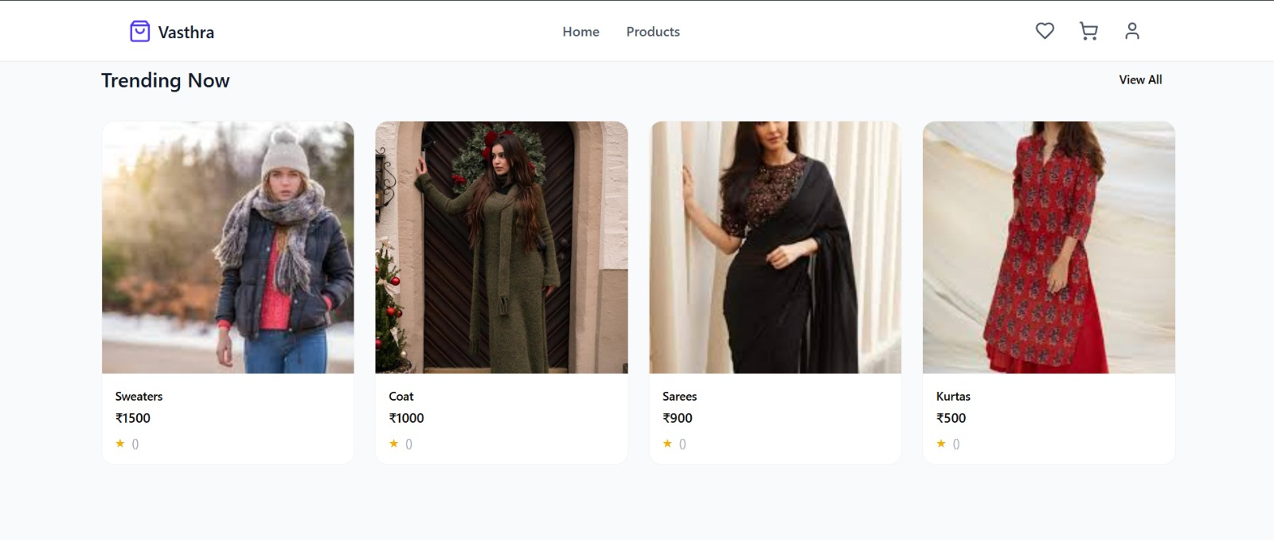

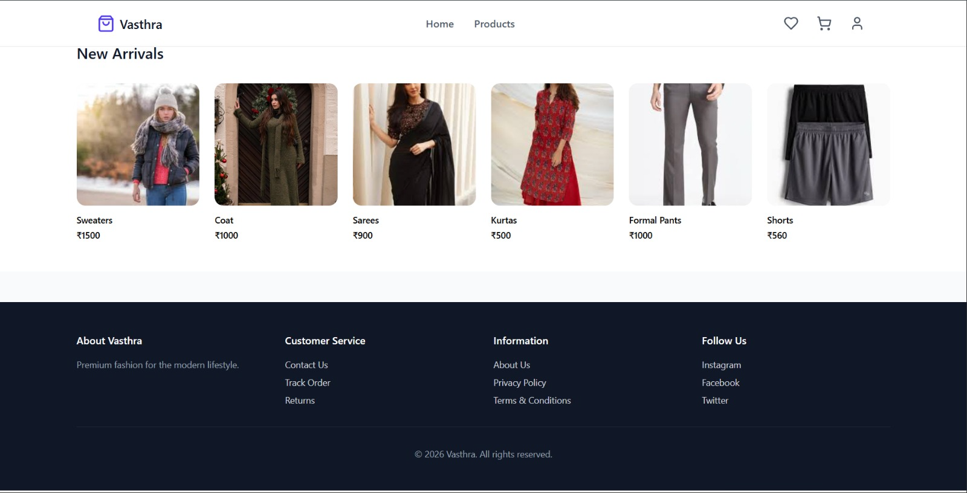

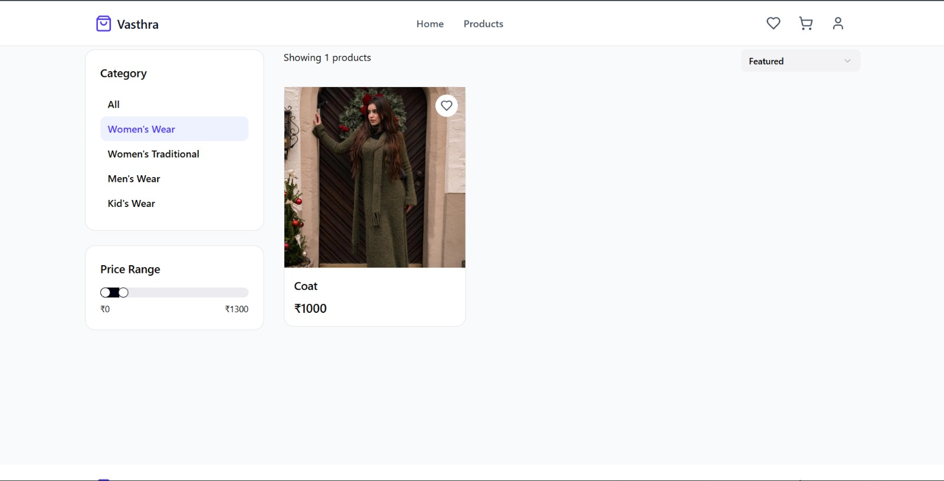

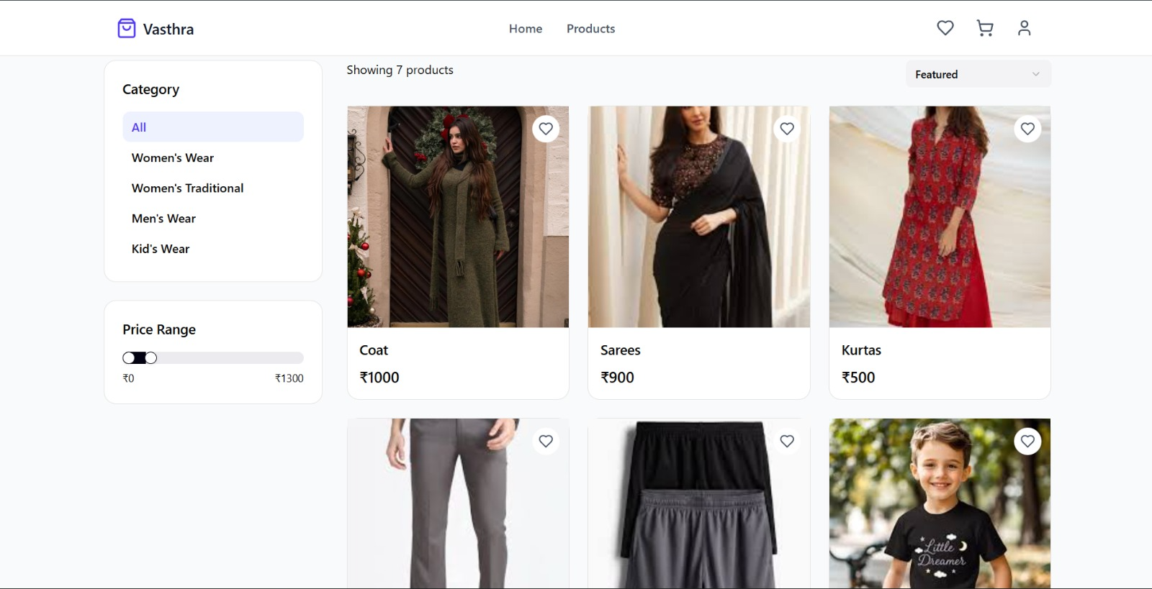

* **Cart Page**

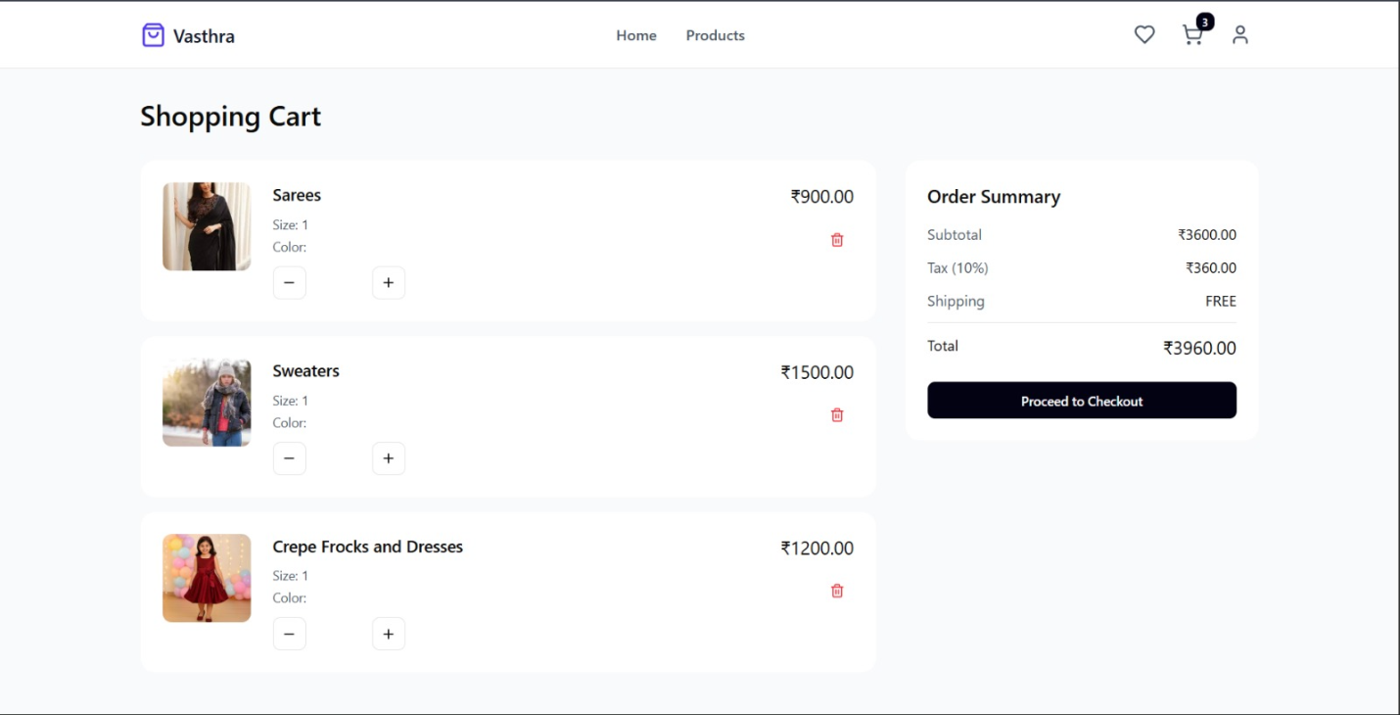

* **Wish List Page**

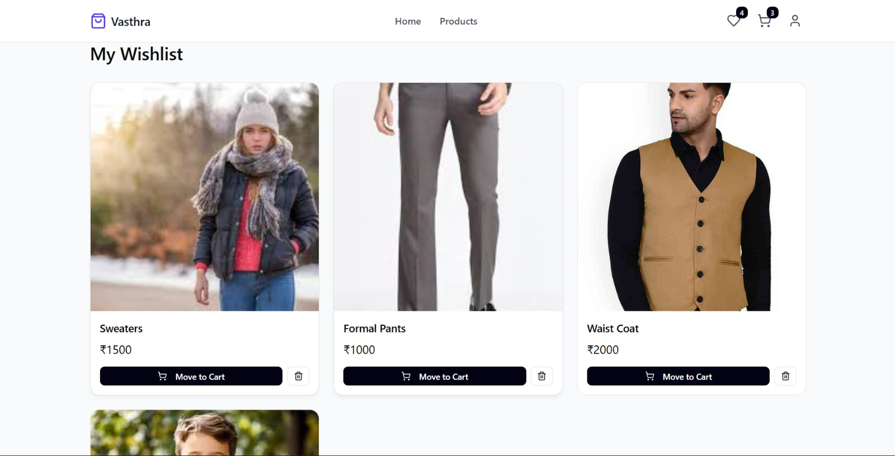

* **Checkout Page**

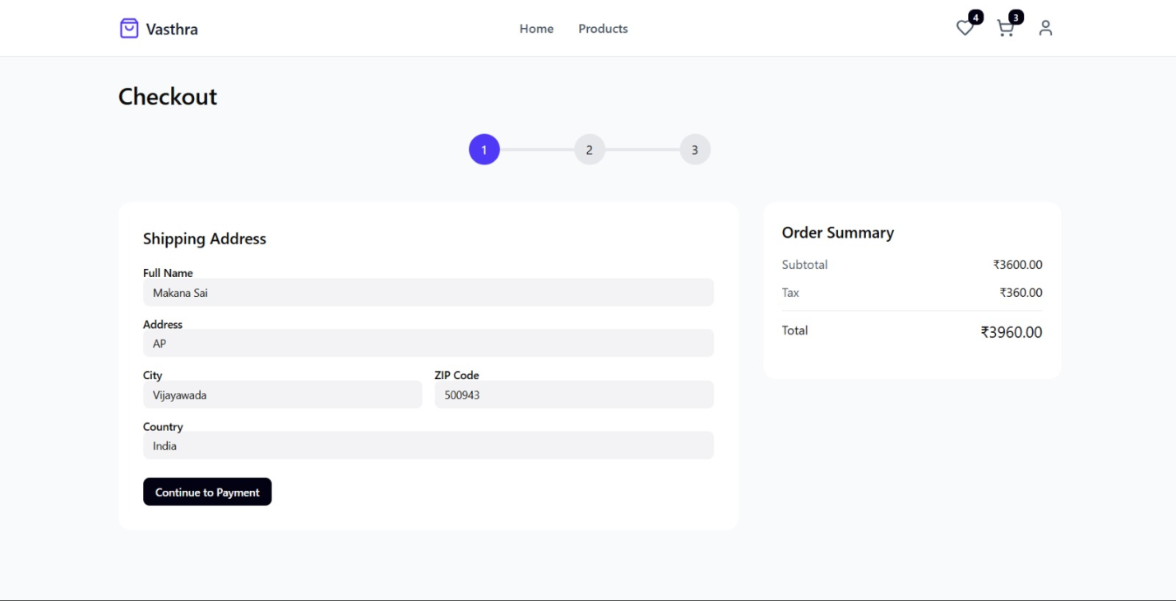

* **Payment Page**

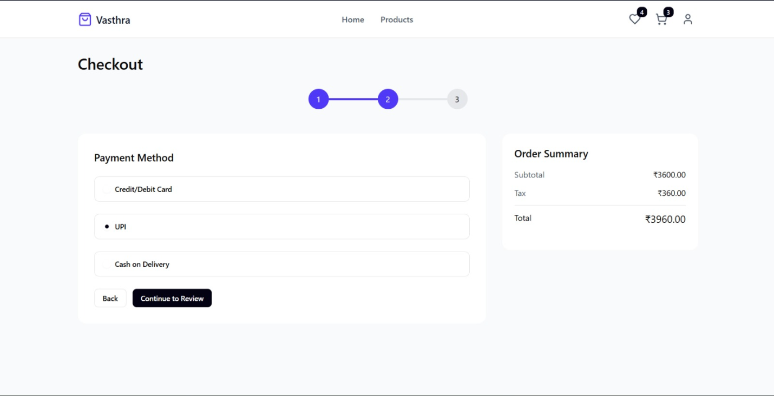

* **Order Summary**

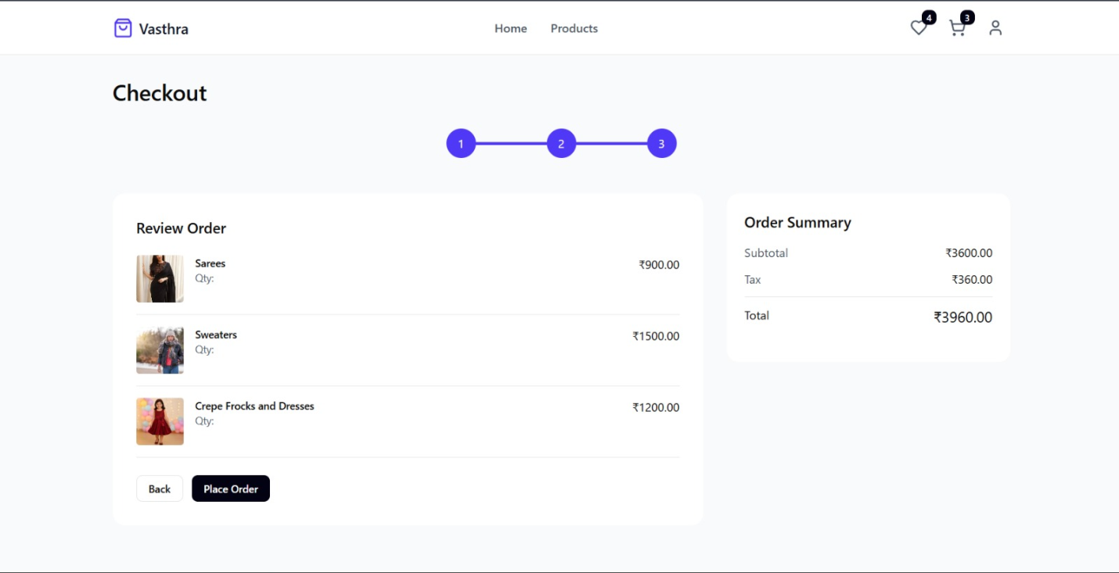

* **Order Success Page**

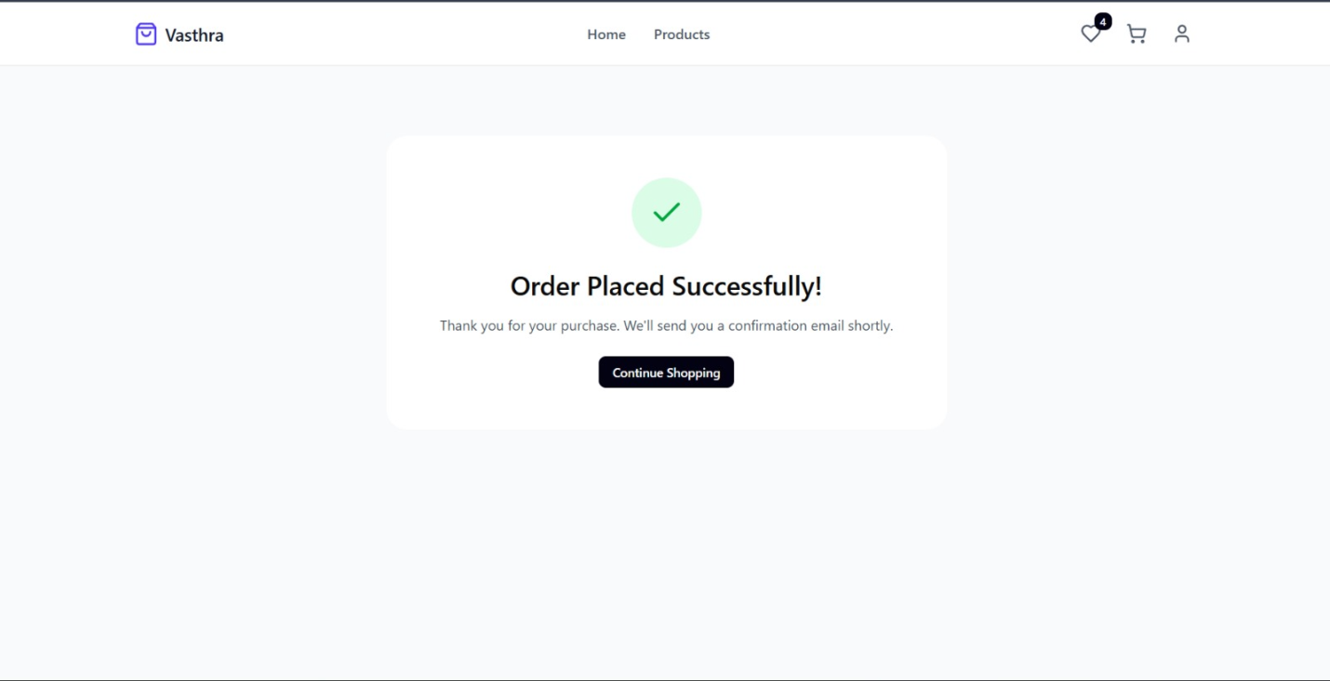

* **Profile page**

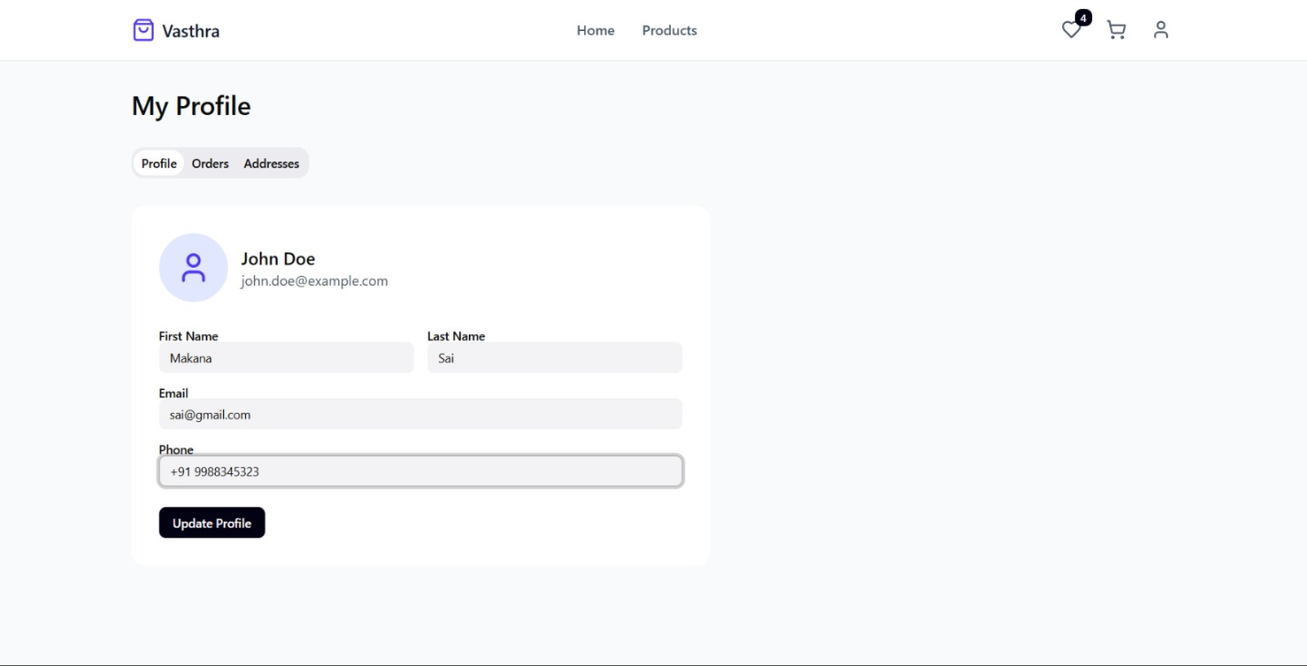

* **Swagger**

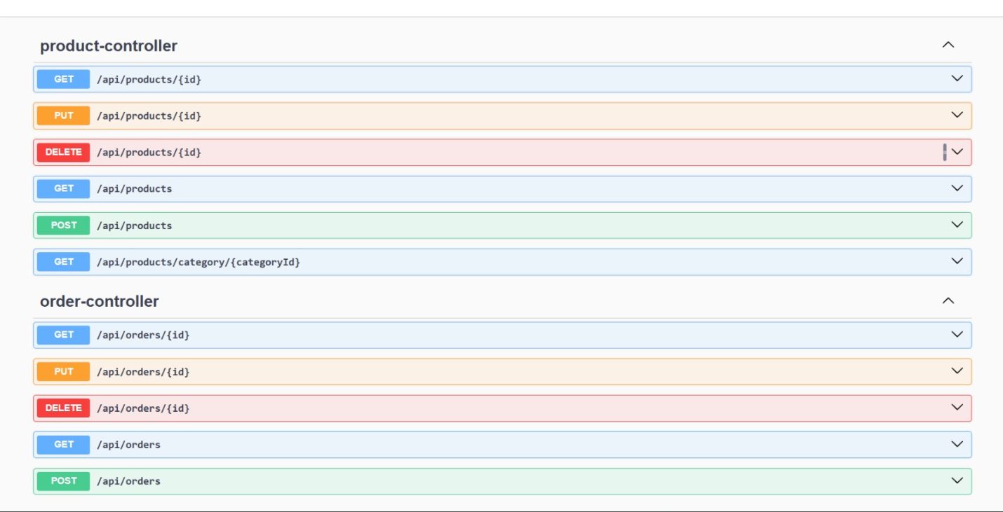

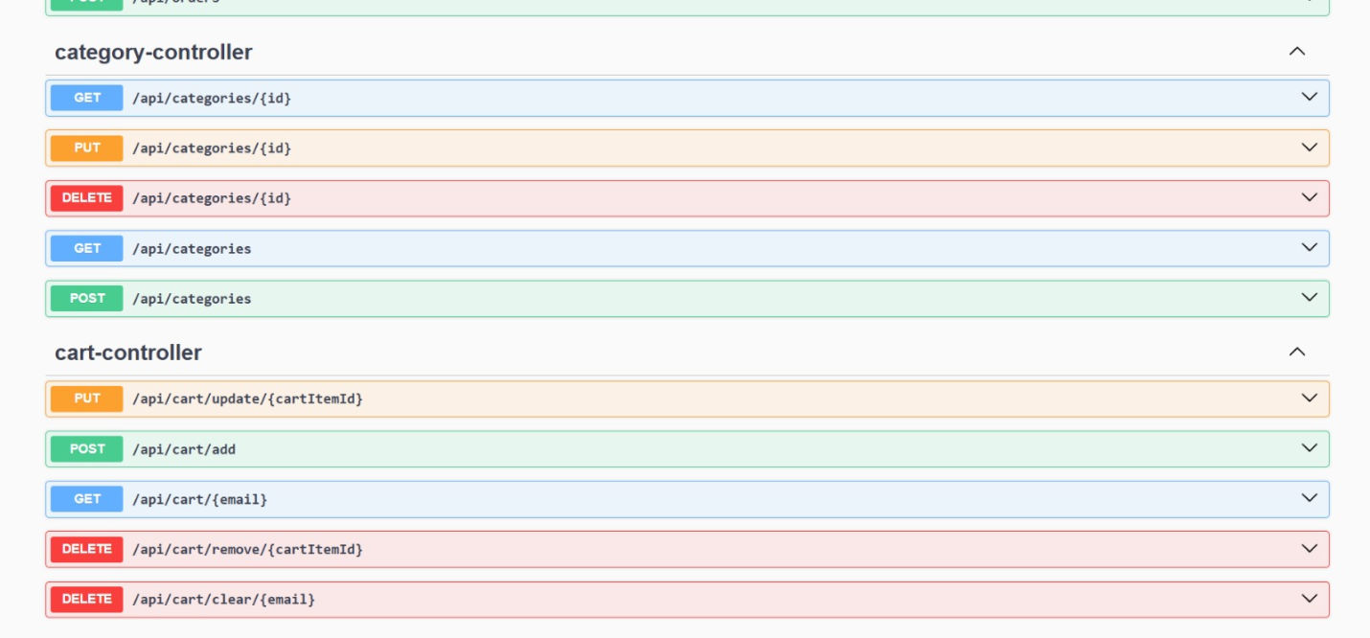

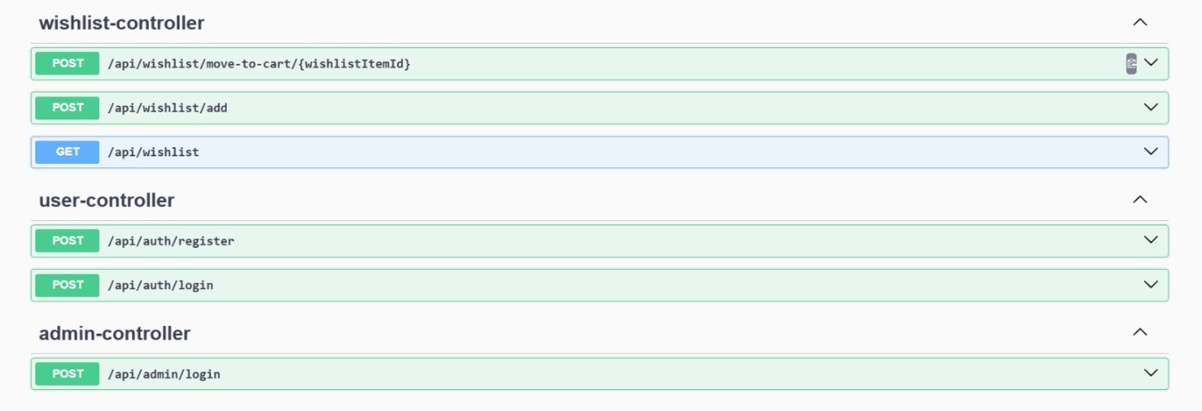

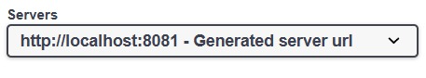

* **Post Man**

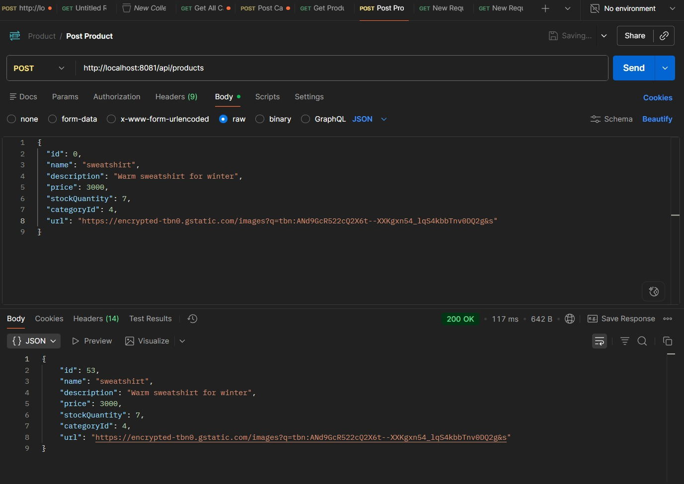

* **SQL**

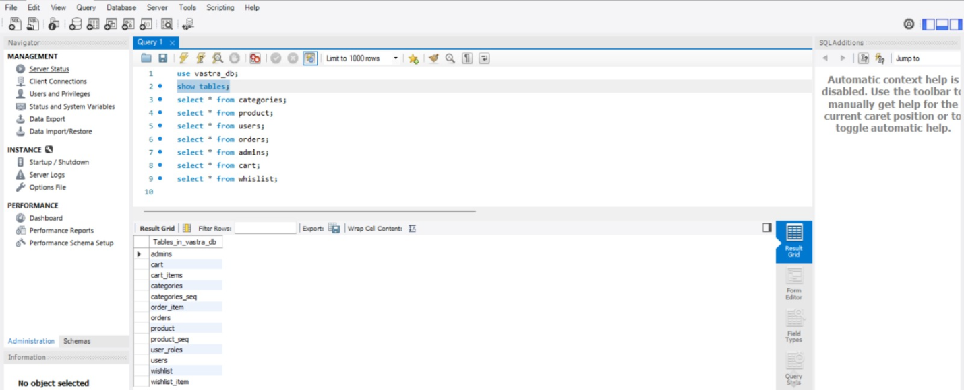

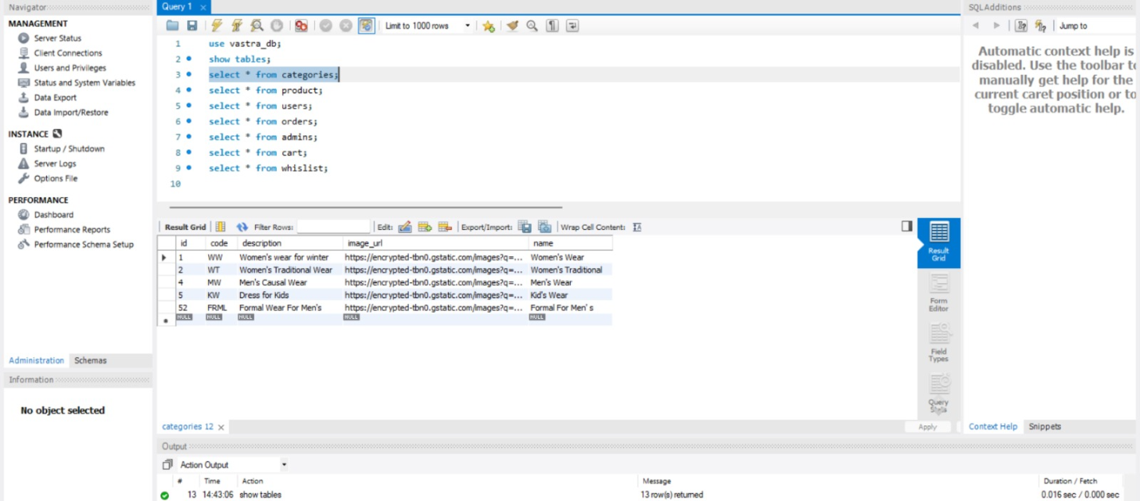

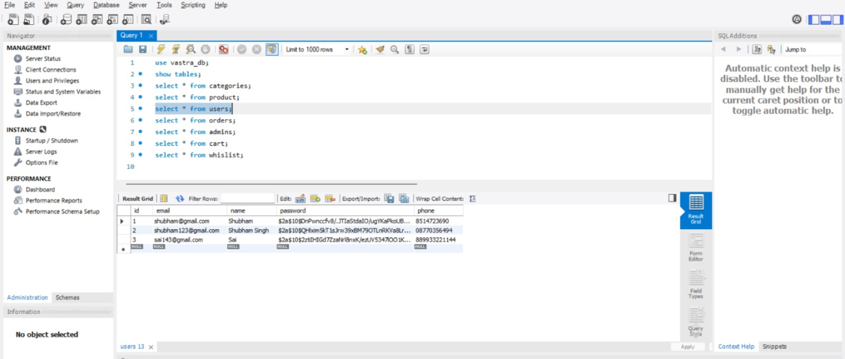

**Git Hub Link**

**https://github.com/divyashreesgaonkar-ui/Vastra-Ecommerce-Clothing-Application**